***Directions: Provide a snippet of each figure in the tutorials below.***

**Tutorial 8-1 (Pg. 504):**

1. Figure 8-9:

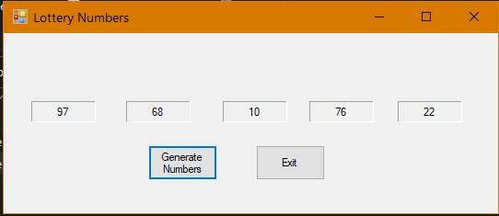

**Tutorial 8-2 (pg. 507):**

1. Figure 8-12:

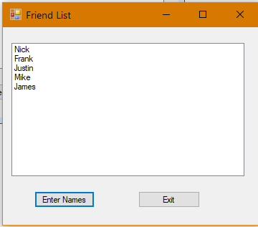

**Tutorial 8-3 (pg. 510):**

1. Figure 8-14:

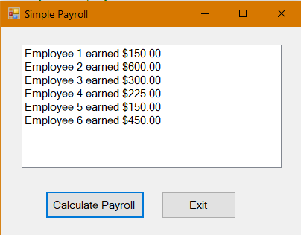

***Continuation of Snippets:***

**Tutorial 8-4 (pg. 518):**

1. Figure 8-19:

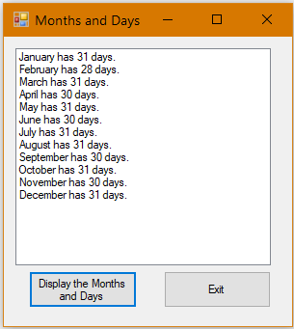

**Tutorial 8-5 (pg. 526):**

1. Figure 8-22:

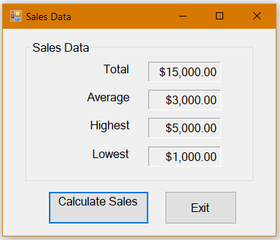

**Tutorial 8-6 (pg. 535):**

1. Figure 8-27:

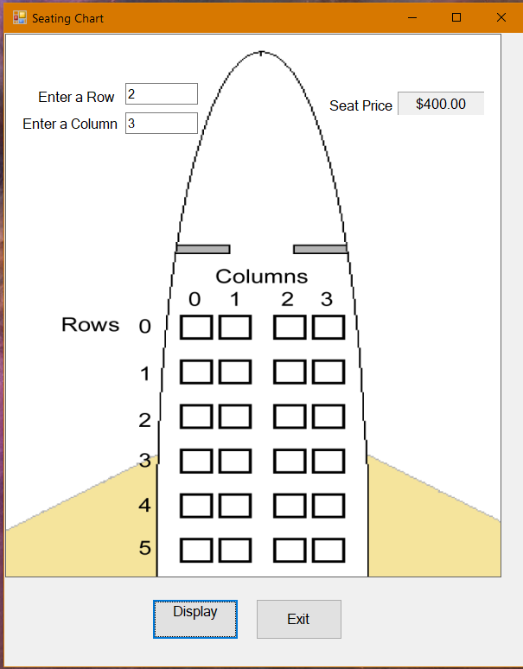

***Continuation of Snippets:***

**Tutorial 8-9 (pg. 551):**

1. Figure 8-44:

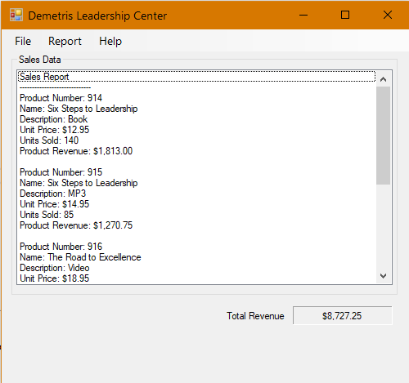

**Tutorial 8-10 (pg. 556):**

1. Step 6 (showing all the names you entered):

